Fixed assets
Land and buildings | 400,000
Machinery | 200,000
Total |  | 600,000
Current assets
Stocks (of the finished product which is ready for sale) | 30,000
Debtors (Money that is owed to the business from customers) | 100,000
Cash | 60,000
Total | 190,000
Less
Current liabilities
Creditors (Money that is owed by the business to suppliers) | 160,000
Bank overdraft | -
Total | 160,000
Working capital (net current assets)  (Current assets minus current liabilities) |  | +30,000
Net assets (Working capital plus fixed assets)  = Total value of the business’ assets |  | =630,000
Financed by:
Shareholders’ funds
(Money put into thebusiness by its owners and retained profits)
Share capital | 500,000
Profit and loss account reserves | 30,000
Total | 530,000
Long-term liabilities
Long-term bank loan | 100,000
Capital employed = Shareholders’ funds + Long Term Liabilities  (All money raised should have been spent on assets. The figures should balance. |  | 630,000

Using the figures from the cash-flow forecast and the profit and loss statement below, and the following information, draw up an end-of-year balance sheet for Makeum & Useum Ltd.in the blank template.
Land and buildings 500,000
Machinery 90,000
Stock at the end of the year 20,000
Debtors 30,150
Creditors 40,500
Share capital 630,000
Dividends paid 0
Long-term loans 10,000
Cashflow Forecast
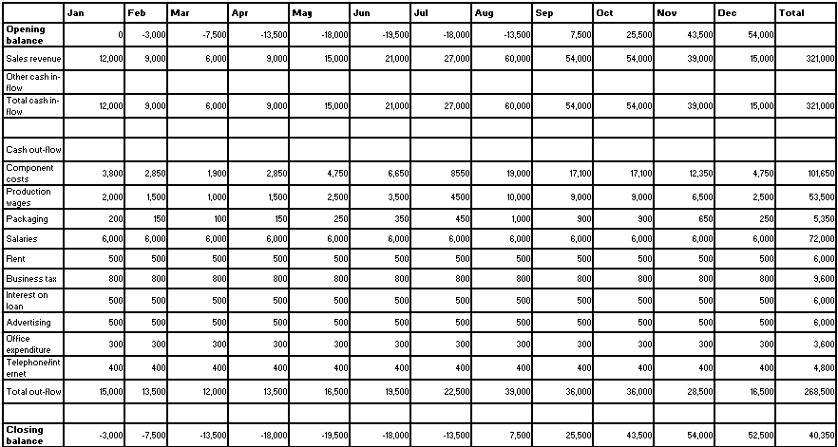

Balance Sheet for Makeum and Useum Ltd.
Fixed assets
Land and buildings
Machinery
Total
Current assets
Stocks
Debtors
Cash
Total
Less
Current liabilities
Creditors
Bank overdraft
Total
Working capital (net current assets)
Net assets
Financed by:
Shareholders’ funds
Share capital
Profit and loss account reserves
Total
Long-term liabilities
Long-term bank loan
Capital employed

Using the information in the cash flow forecast, profit and loss account and balance sheet, write your thoughts about the financial health and performance of Makeum and Useum Ltd.

Some things you might like to consider…
- Cash flow – do they run out often? What problems might that lead to? How could they be avoided/solved?
- Profit and loss account – are the results good? What might be the reason? How could they be improved?
- Balance sheet – is there anything concerning about it? Would shareholders be happy about the dividend situation?

Fixed assets
Land and buildings | 500,000
Machinery | 90,000
Total |  | 590,000
Current assets
Stocks (of the finished product which is ready for sale) | 20,000
Debtors (Money that is owed to the business from customers) | 30,150
Cash | 40,350
Total | 90,500
Less
Current liabilities
Creditors (Money that is owed by the business to suppliers) | 40,500
Bank overdraft | -
Total | 40,500
Working capital (net current assets)  (Current assets minus current liabilities) | 50,000
Net assets (Working capital plus fixed assets)  = Total value of the business’ assets |  | 640,000
Financed by:
Shareholders’ funds
(Money put into thebusiness by its owners and retained profits)
Share capital | 630,000
Profit and loss account reserves | 0
Total
Long-term liabilities
Long-term bank loan | 10,000
Capital employed = Shareholders’ funds + Long Term Liabilities  (All money raised should have been spent on assets. The figures should balance. |  | 640,000

